Spindle Replacement Instructions
You need to use the whole of the replacement block sent.
Do not try to remove the middle spindle from the block.
The main issue is to get the old spindle out of your chair frame.
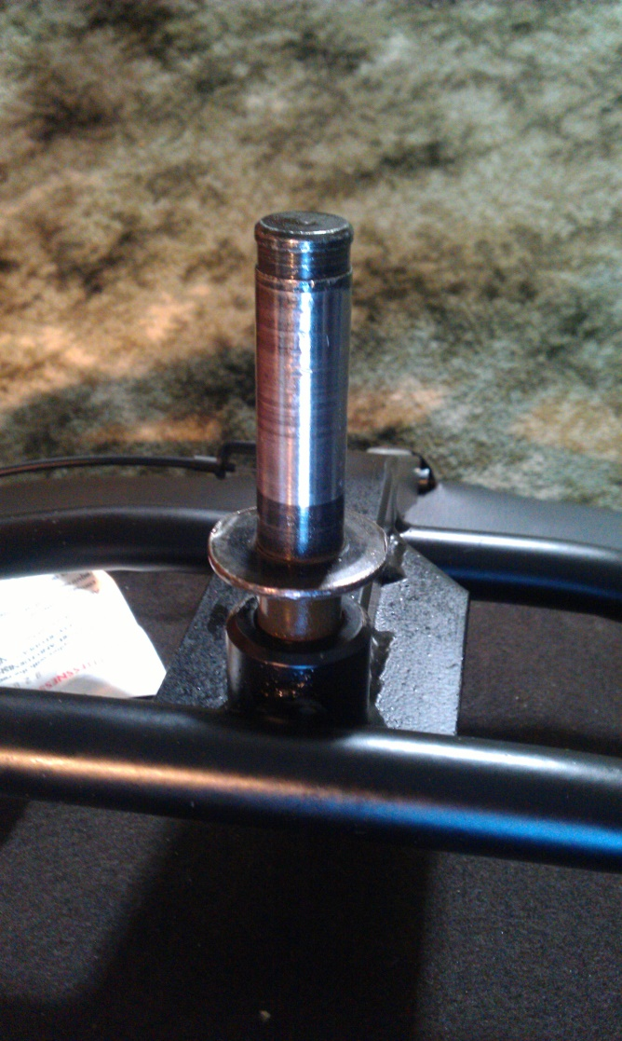
This must be done by tapping the old spindle out from the top end of the frame in a downwards manner.
It will only come out this way as it is conical shaped.
You can undo the front end of the seat to give some more tapping room.
Once you have this out, simply bolt on the legs to the new spindle (some original bolts seem to be long enough and some need to be replaced by longer ones. M8 diameter, 35mm length, and place this back into the chair frame.
RESULT!

